

*Siblings of the invited guests are welcome to come along and skate, but are required to pay regular admission and skate rental fees.

**PLEASE don’t forget to bring socks!**

Skate South is located at SE 5th and County Line Rd. about 1 mile directly south of Southridge Mall in Des Moines

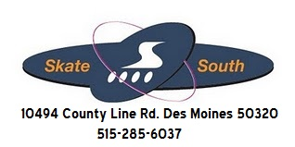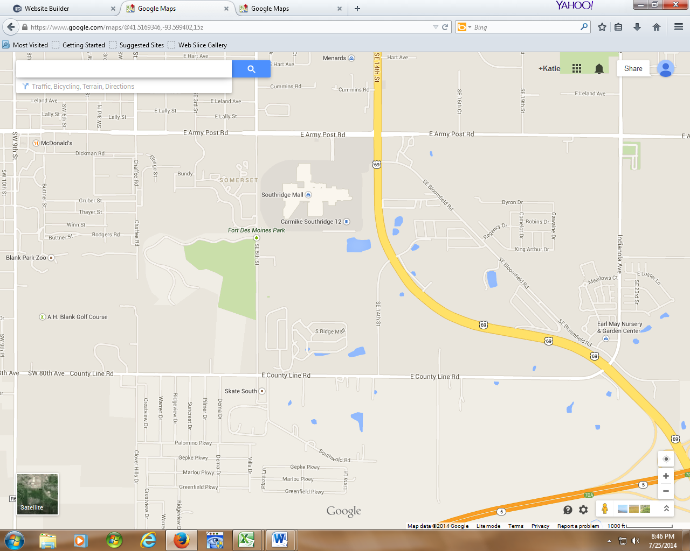

**ARMY POST RD**.

**SE 5th ST**

**SW 9th ST.**

Blank Park Zoo

**SKATE SOUTH**

**Skate South**

**10494 County Line Rd**

**Des Moines, IA 50320**

**Southridge Mall**

|  |
| --- |
| C:\Users\User\Pictures\roo party.jpg |